**DAY 4**

**SESSION 1**

**Component Interaction - Master / Detail Component**

**Employeelist.component.ts:**

import { Component, OnInit } from '@angular/core';

@Component({

selector: 'app-employeelist',

templateUrl: './employeelist.component.html',

styleUrls: ['./employeelist.component.css']

})

export class EmployeelistComponent implements OnInit {

employeeList:Employee[]=[];

ngOnInit(){

this.employeeList = [{id:1, name:"John", salary:5000, permanent:true, department:[{id:3, name:"Payroll"}],skills:[{id:1, name:"HTML"}] },

{id:2, name:"Smith", salary:10000, permanent:true, department:[{id:6, name:"Internal"}],skills:[{id:2, name:"JAVA"}] },

{id:3, name:"Mary", salary:55000, permanent:true, department:[{id:2, name:"Lead"}],skills:[{id:1, name:"HTML"}] },

{id:4, name:"Sandy", salary:15000, permanent:true, department:[{id:3, name:"Payroll"}],skills:[{id:3, name:"CSS"}] },

{id:5, name:"Martin", salary:20000, permanent:true, department:[{id:2, name:"Lead"}],skills:[{id:1, name:"HTML"}] }

]

}

public searchKey:string="";

Search()

{

if(this.searchKey != "")

{

this.employeeList = this.employeeList.filter(res=>{

return res.name.toLocaleLowerCase().match(this.searchKey.toLocaleLowerCase());

});

}

else if(this.searchKey == "")

{

this.ngOnInit();

}

}

}

interface Department{

id:number;

name:string;

}

interface Skill{

id:number;

name:string;

}

interface Employee extends Department, Skill{

id:number;

name:string;

salary:number;

permanent:boolean;

department:Department[];

skills:Skill[];

}

**Employeelist.component.html:**

<h3>Employee List</h3>

<div style="margin: 20px;">

Search &nbsp;

<input type="text" placeholder="Find by name" [(ngModel)]="searchKey" (input)="Search()">

</div>

<div class="row">

<div class="container" *ngFor="let emp of employeeList">

<div class="column" style="padding:5px;">

<div class="cardblock" style="width: 18rem;border: 2px solid #000000;border-color:#0645AD;padding:5px;">

<span style="font-size: 30px;">{{emp.name}}</span>

<span style="float:right ;"> <a style="color: red;" [routerLink]="['/emp-info',emp.id]">emp-info</a></span>

<br>

{{emp.salary | currency : "INR"}}<br>

<a class="editLink" [routerLink]="['/edit-emp-reactive',emp.id]">Edit</a>

</div>

</div>

</div>

</div>

**Emp-info.component.ts:**

import { Component, Input, OnInit } from '@angular/core';

import { ActivatedRoute } from '@angular/router';

@Component({

selector: 'app-emp-info',

templateUrl: './emp-info.component.html',

styleUrls: ['./emp-info.component.css']

})

export class EmpInfoComponent implements OnInit {

ngOnInit(): void {

}

empObj :any={};

@Input() employee = [{id:1, name:"John", salary:5000, permanent:true, department:[{id:3, name:"Payroll"}],skills:[{id:1, name:"HTML"}] },

{id:2, name:"Smith", salary:10000, permanent:true, department:[{id:6, name:"Internal"}],skills:[{id:2, name:"JAVA"}] },

{id:3, name:"Mary", salary:55000, permanent:true, department:[{id:2, name:"Lead"}],skills:[{id:1, name:"HTML"}] },

{id:4, name:"Sandy", salary:15000, permanent:true, department:[{id:3, name:"Payroll"}],skills:[{id:3, name:"CSS"}] },

{id:5, name:"Martin", salary:20000, permanent:true, department:[{id:2, name:"Lead"}],skills:[{id:1, name:"HTML"}] }

]

constructor(private route:ActivatedRoute)

{

let eno = this.route.snapshot.params["id"];

this.empObj = this.employee.find( item => item.id == eno );

}

}

interface Department{

id:number;

name:string;

}

interface Skill{

id:number;

name:string;

}

interface Employee extends Department, Skill{

id:number;

name:string;

salary:number;

permanent:boolean;

department:Department[];

skills:Skill[];

}

**Emp-info.component.html:**

<h2>Employee Details</h2>

<div class="cardblock">

<br>

Name : {{empObj.name}}

<br>

<br>

Salary : {{empObj.salary | currency : "INR"}}

<br>

<br>

Permanent : {{empObj.permanent}}

<br>

<br>

<a class="editLink" [routerLink]="['/edit-emp-reactive',empObj.id]">Edit</a>

</div>

**Output:**

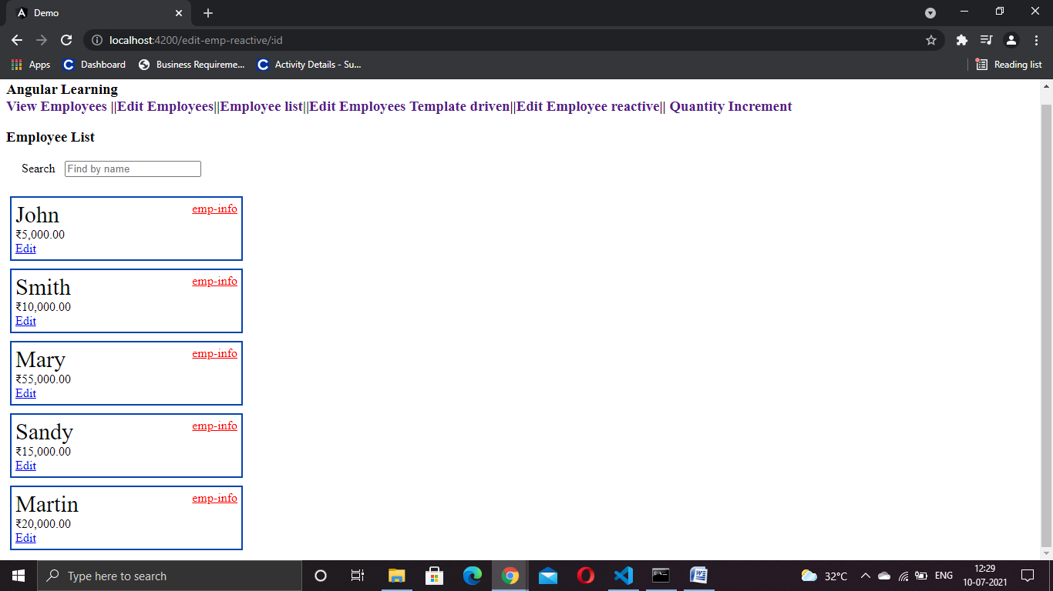

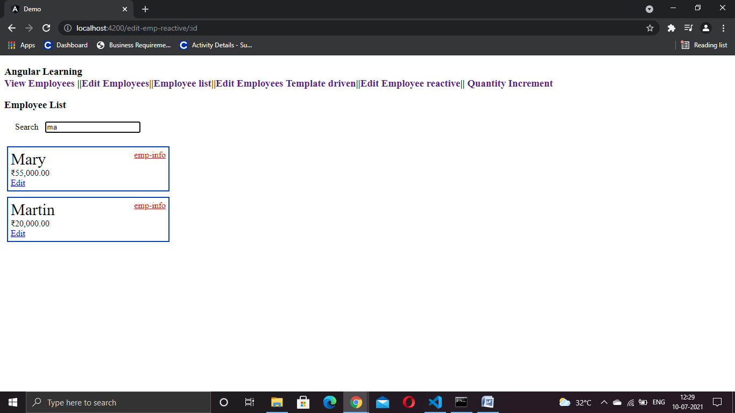

**SESSION 2**

**Service - Create service for handling employee data**

**Employee.service.ts**

import { Injectable } from '@angular/core';

@Injectable({

providedIn: 'root'

})

export class EmployeeService {

employeeList:Employee[]= [{id:1, name:"John", salary:5000, permanent:true, department:[{id:3, name:"Payroll"}],skills:[{id:1, name:"HTML"}] },

{id:2, name:"Smith", salary:10000, permanent:true, department:[{id:6, name:"Internal"}],skills:[{id:2, name:"JAVA"}] },

{id:3, name:"Mary", salary:55000, permanent:true, department:[{id:2, name:"Lead"}],skills:[{id:1, name:"HTML"}] },

{id:4, name:"Sandy", salary:15000, permanent:true, department:[{id:3, name:"Payroll"}],skills:[{id:3, name:"CSS"}] },

{id:5, name:"Martin", salary:20000, permanent:true, department:[{id:2, name:"Lead"}],skills:[{id:1, name:"HTML"}] }]

getAllEmployees() : Employee[]{

return this.employeeList;

}

getEmployee(employeeId: number){

return this.employeeList.filter(e=>e.id===employeeId);

}

}

export interface Department{

id:number;

name:string;

}

interface Skill{

id:number;

name:string;

}

interface Employee extends Department, Skill{

id:number;

name:string;

salary:number;

permanent:boolean;

department:Department[];

skills:Skill[];

}

Guard – AuthService

**Auth.service.ts**

**import { Injectable } from '@angular/core';**

**@Injectable({**

**providedIn: 'root'**

**})**

**export class AuthService {**

**constructor() { }**

**loggedIn!: boolean;**

**login()**

**{**

**this.loggedIn=true;**

**}**

**logout()**

**{**

**this.loggedIn=false;**

**}**

**isLoggedIn():boolean**

**{**

**return this.loggedIn;**

**}**

**}**

**Guard - Protect Component using Guard**

import { Injectable } from '@angular/core';

import { ActivatedRouteSnapshot, CanActivate, RouterStateSnapshot, UrlTree } from '@angular/router';

import { Observable } from 'rxjs';

import { AuthService } from '../auth.service';

import { Router, ActivatedRoute, ParamMap } from '@angular/router';

@Injectable({

providedIn: 'root'

})

export class AuthGuard implements CanActivate {

constructor(private authService: AuthService,

private router: Router) { }

canActivate(

next: ActivatedRouteSnapshot,

state: RouterStateSnapshot): Observable<boolean | UrlTree> | Promise<boolean | UrlTree> | boolean | UrlTree {

if (this.authService.isLoggedIn()) {

return true;

}

else{

this.router.navigate(['/login']);

}

return false;

}}